**Sample Post 1**

Are you feeling as if life is too much? Or do you simply want to live a fuller life with more balance?

The Mindfulness-Based Stress Reduction (MBSR) course is a great place to start or continue your journey into mindfulness. MBSR helps you learn mindfulness with enough time and practice to integrate it into your life with hands-on practices that help you “make mindfulness your own.”

Register Today:

<https://www.workingmindfulness.com/mbsr-program>

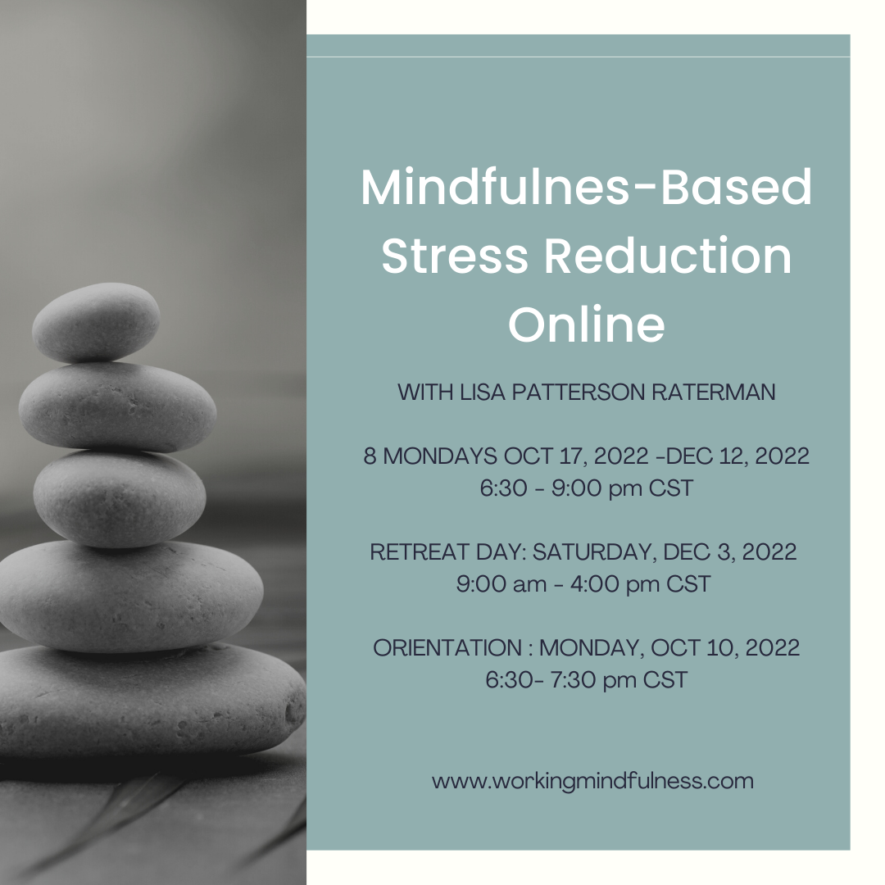

**Sample Post 2**

The Mindfulness-Based Stress Reduction hybrid fall course starts Monday, October 10th. Sign up today to reduce stress, feel healthier, improve emotional well-being, and connect fully to your life. Learn more at <https://www.workingmindfulness.com/mbsr-program>

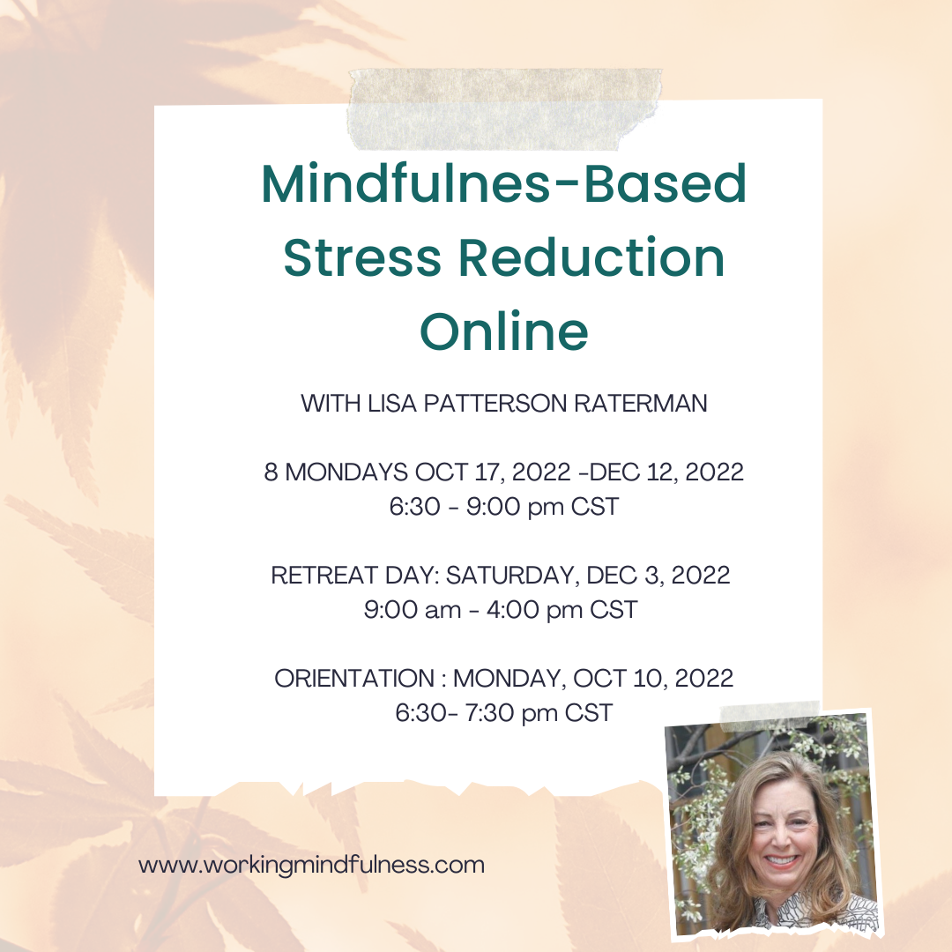

**Sample Post 3**

Mindfulness-Based Stress Reduction 8-week course starting next week, September 10. Register at <https://www.workingmindfulness.com/mbsr-program>

