**Post 1:**

Mindfulness meditation is often shrouded in mystery, but in reality it's very easy to practice.

Link: <https://www.msn.com/en-ca/health/wellness/10-reasons-to-practice-mindfulness-meditation/ss-AAXEcys?fbclid=IwAR2UX15PG1_SY0LnPvDj07Tcm7ehrwHDiKEfGKmk8YdLmi4fcDvJVLEWLf4>

**Post 2:**

Have you ever tried meditation and found it challenging?

Do you hear about mindfulness and its benefits but need help working it into your daily life?

Join Lisa Patterson Raterman, [via Zoom,](https://us02web.zoom.us/j/86239730176?pwd=NUpLODhvaFFLNm0yaUh6TWtHNVI1dz09) every Wednesday afternoon for a 30-minute mindful pause.

Each week, Lisa will guide you through a new exercise that you can include in your own wellness routine.

Prior experience is optional.

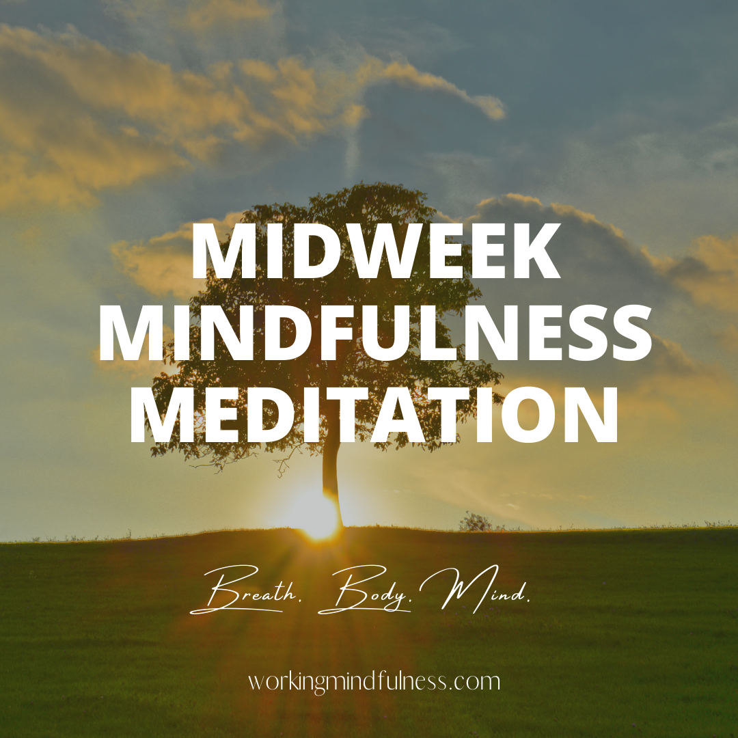

**Post 3:**

Did you know that Meditation is about self-acceptance?

Through meditation, practitioners enter the quietness already in their minds. It is a practice where the individual focuses their mind and intention on the present moment.

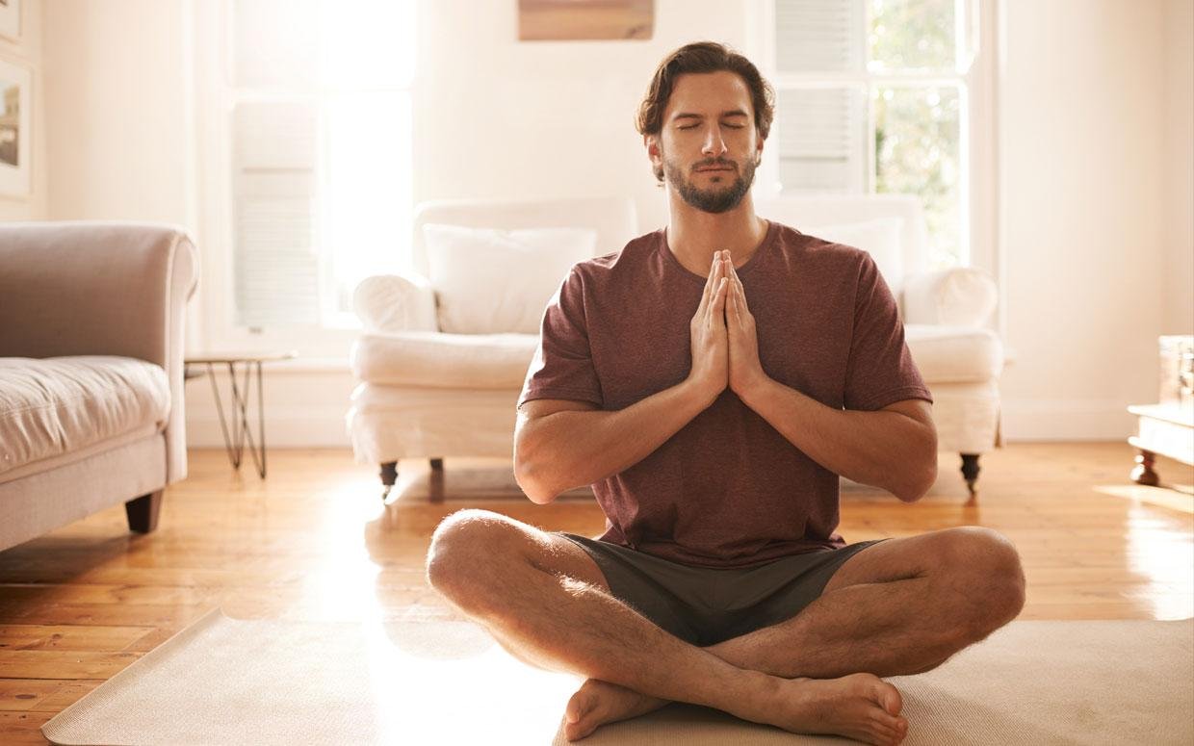

**Post 4:**

Zoom classes are now forming! Join instructor Lisa Patterson Raterman, RN, BSN, for an 8-week MBSR course, meeting Mondays from 6:30 - 9:00 pm starting June 13th. Learn more and register here! ​👉<https://www.workingmindfulness.com/mbsr-program>

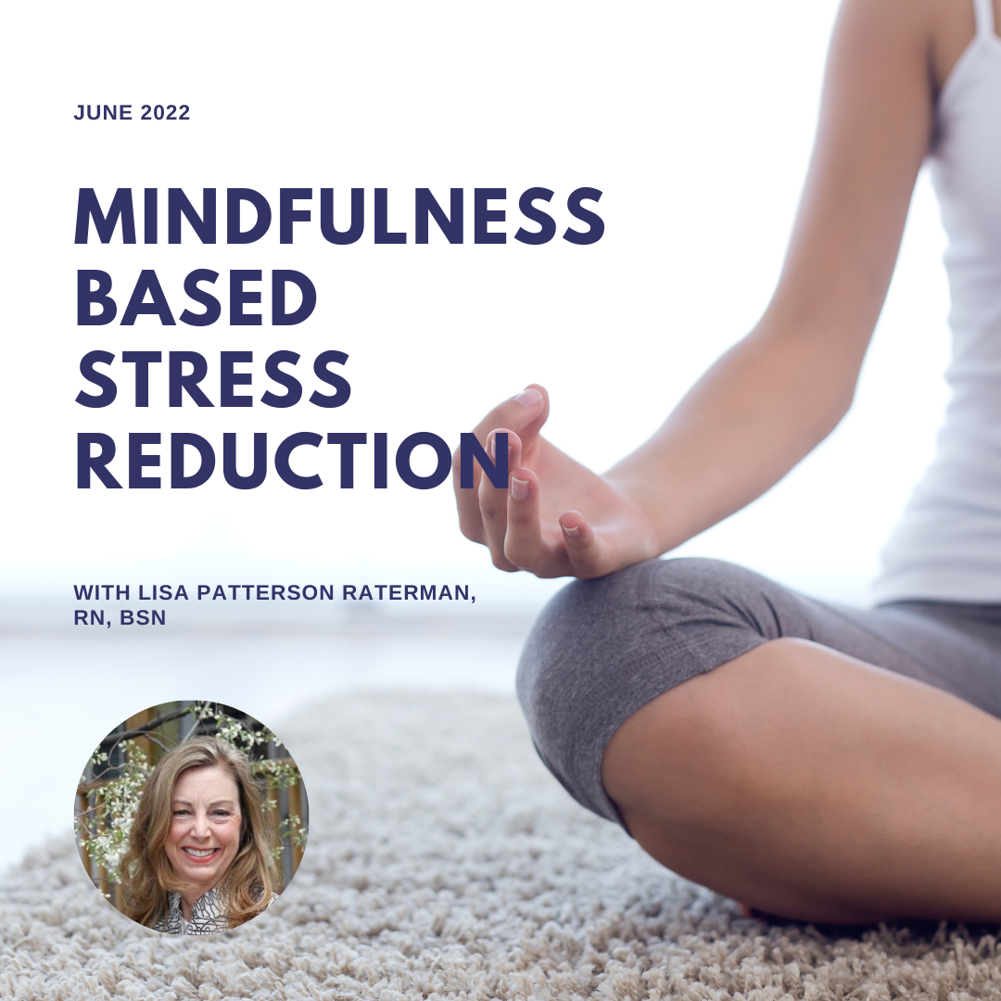

**Post 5:**

What students are saying about Lisa Patterson Raterman's MBSR courses:

